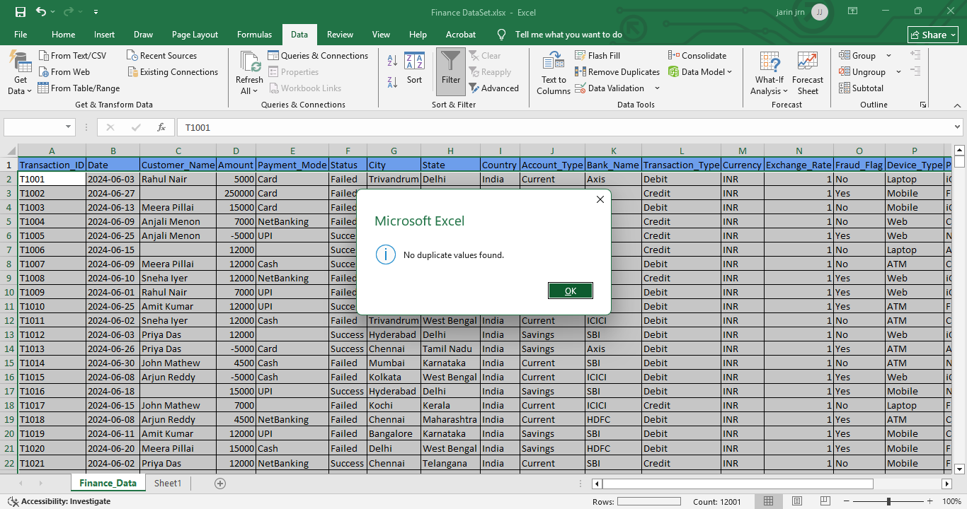
- Data Cleaning and Transformation of Finance_DataSet
Handling Duplicate Values
Step 1: Duplicate values can be handled by removing duplicates
Go to Data -> Data Tools -> Remove Duplicates
Step 2: Select the relevant columns to check for duplicate entries based on your data criteria and if your data has headers make sure “My data has Headers” checked
Step 3: Any duplicate values will be removed. Since no duplicates were found, a pop up will appear stating 'No duplicate values.

2) Validating that all column data types are formatted correctly and update each column as below format
Transaction_ID | General
Date | Date
Customer_Name | Text
Amount | Number
Payment_Mode | Text
Status | Text
City | Text
State | Text
Country | Text
Account_Type | Text
Bank_Name | Text
Transaction_Type | Text
Currency | Text
Exchange_Rate | Number
Fraud_Flag | Text
Device_Type | Text
Platform | Text
Category | Text
Remarks | Text
Duplicate_Flag | Text

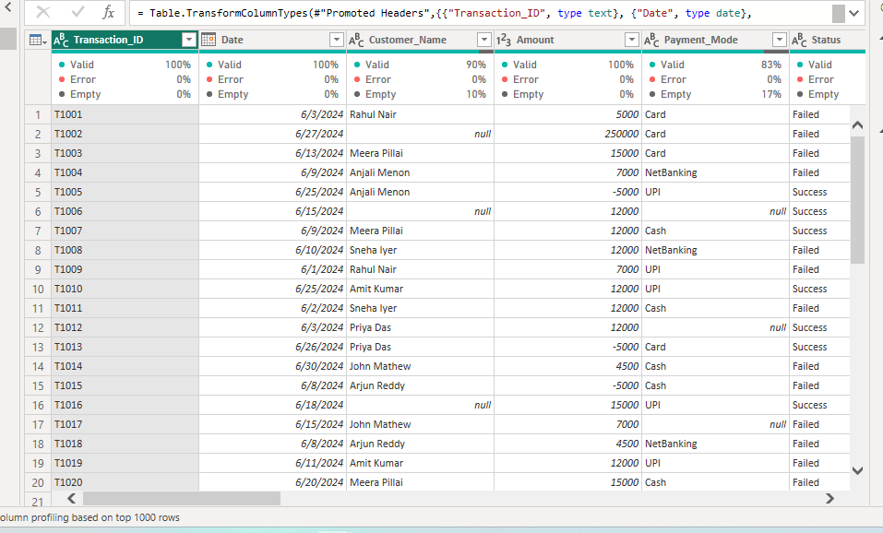
3) Used Power Query editor to check column quality
Customer_Name and Payment_Mode columns contains empty cells. Empty cells are handled using Imputation process
COUNTBLANK() used to find no.of empty cells in a column
Empty cells in Customer_Name column : 1241
=COUNTBLANK(Table1[[#All],[Customer_Name]])
Empty cells are handled by creating new column “Customer_Name_Updated “and filled these column by imputing “unknown” value.
=IF([@[Customer_Name]]<>"",PROPER(TRIM(CLEAN([@[Customer_Name]]))),"Unknown")
Empty cells in Payment_Mode column : 2401
=COUNTBLANK(Table1[[#All],[Payment_Mode]])
Empty cells are handled by creating new column “Payment_Mode_Updated “and filled these column by Mode value “Net Banking”.
=IF([@[Payment_Mode]]<>"",PROPER(TRIM(CLEAN([@[Payment_Mode]]))),"Netbanking")
4) Amount column contains negative values. To handle this new column created as “Amount_Updated” and used ABS()
=ABS([@Amount])
5) There is a mismatch between state and city column. To handle this new column created as “State_Updated” and used IFS()
=IFS([@City]="Trivandrum","Kerala",[@City]="Kochi","Kerala",[@City]="Bangalore","Karnataka",[@City]="Chennai","Tamil Nadu",[@City]="Delhi","Delhi",[@City]="Hyderabad","Telangana",[@City]="Kolkata","West Bengal",[@City]="Mumbai","Maharashtra")
6) There is a mismatch between Device_Type and Platform. To Handle this new column created as “Platform_Updated” and used IFS()
=IFS([@[Device_Type]]="Laptop","Chrome/Firefox",[@[Device_Type]]="Web","Chrome/Firefox",[@[Device_Type]]="Mobile","iOS/Android",[@[Device_Type]]="ATM","ATM")
7) Modifying the “Duplicate_flag” column values to 'No' since all records are unique. Here we can use “find and replace” tool

